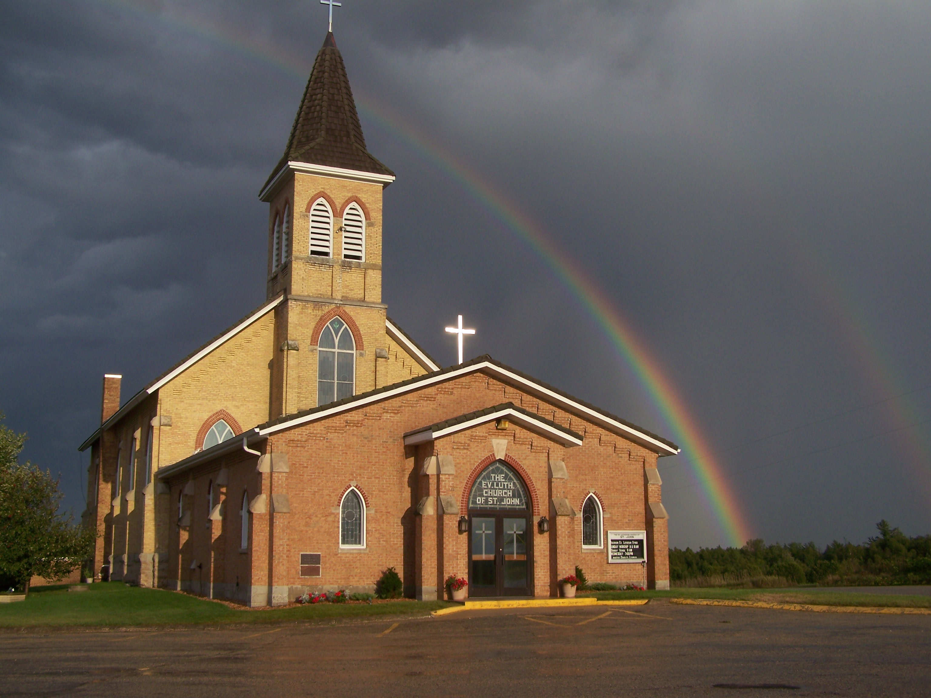
The Evangelical Lutheran Church of St. John
N1916 Church Road
Peshtigo, Wisconsin 54157-9673
Pastor Sargent 920-228-1061

12/23/2020

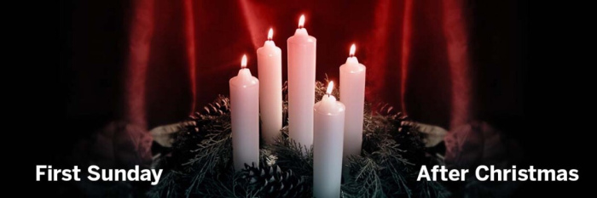

Sunday December 27 is the First Sunday after Christmas. We will be looking at Luke 2:25-40. We find Simeon and Anna praising and thanking God for allowing them the chance to see with their own eyes the promised Savior.
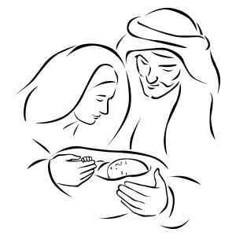

We can also be thankful that, once again, through the eyes of faith, we have had the chance to see and remember how God’s greatest gift to us came into the world.

Lisa, Nathan and I would like to take this opportunity to express our gratitude and thanks for all the cards, well wishes and gifts we have received from member of our congregation. It is our prayer that the Lord will bless us all in this New Year.

Pastor Daniel, Lisa and Nathan Sargent

Important Information:

Bible Study:

There will be a break in our Bible Study lessons during the Christmas/New Year Holidays. There is a plan to begin a new study on the 10th of January 2021.

Sunday School:



Attention Parents!

We are in the Winter Lessons. There will a Christmas and New Year break for Sunday School. The next lesson is set for January 3, 2021. The Lesson will be Gideon’s Victory from Joshua 7. Please let your Sunday School Teacher or Pastor know if you are having any trouble getting the lessons. We know this is a difficult time because of the pandemic. As of now, we are not able to hold in-person classes. We are very concerned about Sunday School want to make sure parents and children are getting the lessons they need. If you have any questions or concerns you can also call Pastor Sargent (920) 228-1061.

Click on https://online.nph.net/ss-remote
to view the videos.



Call Meeting:

There will be a Call Meeting held on Sunday the 27th of December for our Principal and vacant teacher positions at St. John. All voters of the congregation are asked to attend. The meeting will be held after the 10:00 am service.

Worship: If you are not feeling well or have concerns about your own health, you do not need to attend. We will continue with the Livestreaming service at 8:30. If you would like to receive private communion at home please contact Pastor Sargent.

http://www.facebook.com/The-Evangelical-Lutheran-Church-of-St-John-Town-of-Grover-WELS-100389558275581/
https://www.youtube.com/channel/UCJ8tkCadzLHuxGWLhovgl8Q

